Angel Velazquez

Complement of the language L = {w | w has exactly two a’s and odd number of b’s}

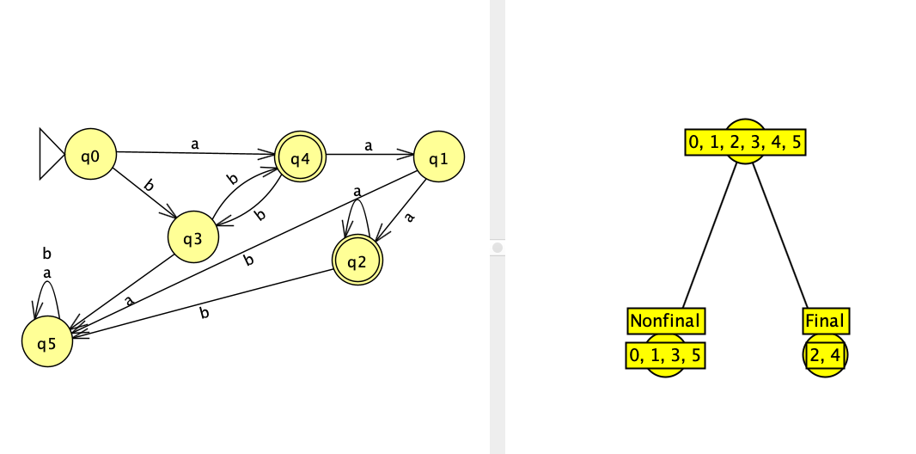

L = {even number of zeros and odd number of ones}